* INTRODUCTION

The banking industry world-wide is being transformed. The global forces for change include technological innovation; the deregulation of financial services at the national level and opening-up to international competition; and - equally important - changes in corporate behavior, such as growing disintermediation and increased emphasis on shareholder value. In addition, recent banking crises in Asia and Latin America have accentuated these pressures. The banking industries in central Europe and Latin America have also been transformed as a result of privatizations of state-owned banks that had dominated their banking systems in the past. In this project we are trying to analysis the bank related data and able to extract some insights from the data using Business Intelligence tools. To Extract the Insights from the data and put the data in the form of visualizations, Dashboards and Story we employed Tableau tool.

* PROBLEM DEFINITION & DESIGN THINKING

The business requirements for analyzing the performance and efficiency of banks  in world include identifying KPIs, comparing performance across different countries and states, identifying patterns and trends over time, identifying affecting factors, creating interactive dashboards and reports, identifying areas for improvement, making data-driven decisions, comparing to the industry average and creating forecasting models for future performance. The ultimate goal is to gain insights and improve performance through data visualization techniques.

2.1 EMPATHY MAP

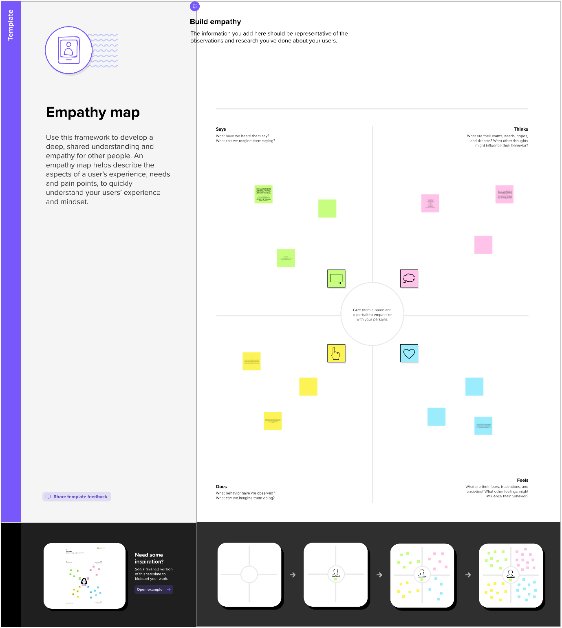

2.2 IDEATION &BRAINSTORMING MAP

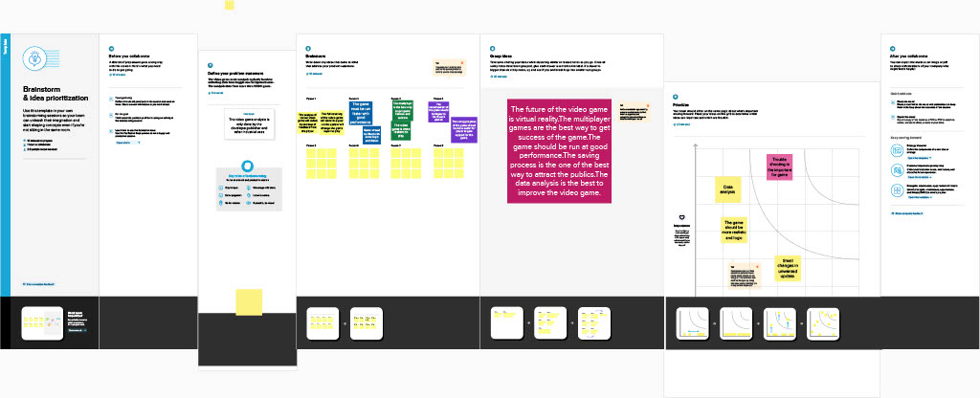

* RESULT

A literature survey for the financial analysis of banks would involve researching and reviewing previous studies, articles, and reports on the topic. This could include information on the methods and techniques used for financial analysis of banks, as well as the results and conclusions of these studies.

* ADVANTAGES

Risk management, which involves identifying, assessing, and mitigating the various risks facing a bank, such as credit risk, market risk, and operational risk, which is a set of international regulatory standards for banks that includes measures for capital adequacy, liquidity, and leverage.

* DISADVANTAGES

Financial analysis of banks can have a significant social impact by identifying areas where the bank's operations or lending practices may be causing harm to vulnerable communities or perpetuating inequality. For example, a financial analysis might reveal that a bank is heavily invested in fossil fuel companies, contributing to climate change, or that the bank is disproportionately denying loans to minority-owned businesses, perpetuating economic discrimination.

* APPLICATIONS

Data collection is the process of gathering and measuring information on variables of interest, in an established systematic fashion that enables one to answer stated research questions, test hypotheses, evaluate outcomes and generate insights from the data

* CONCLUSION

Data visualization is the process of creating graphical representations of data to help people understand and explore the information. The goal of data visualization is to make complex data sets more accessible, intuitive, and easier to interpret. By using visual elements such as charts, graphs, and maps, data visualizations can help people quickly identify patterns, trends, and outliers in the data.

* FUTURE SCOPE

A data story is a way of presenting data and analysis in a narrative format, intending to make the information more engaging and easier to understand. A data story typically includes a clear introduction that sets the stage and explains the context for the data, a body that presents the data and analysis logically and systematically, and a conclusion that summarizes the key findings and highlights their implications.

* APPENDIX

1. SOURCE CODE

* Dashboard : <https://public.tableau.com/views/Abi1_16815343111810/Dashboard1?:language=en-GB&:display_count=n&:origin=viz_share_link>
* Story : <https://public.tableau.com/views/Abi3_16815346346860/Story1?:language=en-GB&publish=yes&:display_count=n&:origin=viz_share_link>